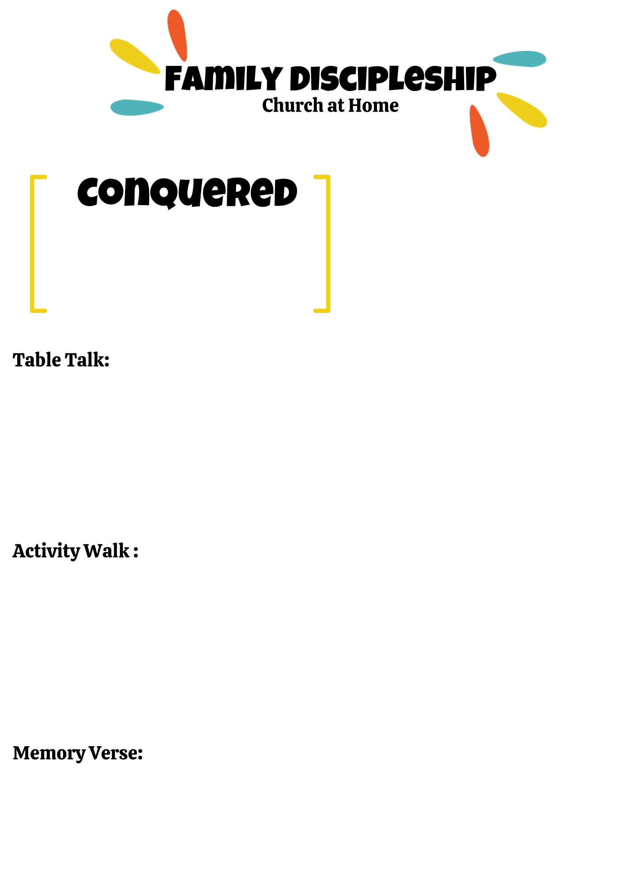
Jo
ADVENT: HOPE
Spend a minute discussing the HOPE Rahab felt knowing her family was going to be saved. The HOPE Joshua felt of finally entering the land of Promise. And the HOPE we have of a returning Savior.

- Take some time this week to play hide and seek or sardines (backwards hide & seek) as a family. Play outside or inside depending on weather.
- Make a “scarlet chord” together as a family. This could be a paper chain of red links, a printed piece of paper with red lines, a fancy braided ribbon… At the dinner table one night discuss how God has provided for your family and write it on the scarlet chord. Place somewhere in the house as a reminded of God’s provisions.
- Take time to go back and read God’s promise to Abraham (Genesis 12:1-3) The Israelites have been 40 years in the desert wandering, finally it is time to enter the land promised to Abraham.

Read Joshua 2 May want to read in storybook bible or summarize the story
Why did Rahab choose to hide the spies? (vs 10-11)
What did Rahab hear about the Lord God?
What are messages you hear about the Lord God today?
What are some amazing things the Lord has done in your family?
Do others around you hear about the amazing things God has done?
How does remembering all that God has done, allow for your trust in God to be strengthened?
What are other stories in the bible does the scarlet chord remind you of?

Big Idea: God prepares his people to
enter a place of promise.

Why is God worthy of our trust?

Week 1
Joshua 1:9 NLT
"This is my command—be strong and courageous! Do not be afraid or discouraged. For the Lord your God is with you wherever you go.”

